School of Computer Science and Mathematics

Data Structures and Algorithms
Student (Last Name, First Name): Alexandr Kim

Assignment 6: Recursion

Part A “Recursion” (20 exercises)
№ | Task
1 | Factorial Calculation:  Task: Write a recursive function to calculate the factorial of a given non-negative integer.  Example: factorial(5) should return 120 (5 * 4 * 3 * 2 * 1).  Code (ex1.cpp):  #include <iostream>  using namespace std;  long long factorial(int n) {  if (n <= 1) return 1;  return n * factorial(n - 1);  }  int main() {  int n;  cout << "Enter a non-negative integer: ";  cin >> n;  cout << "Factorial = " << factorial(n);  return 0;  }  Screenshot:  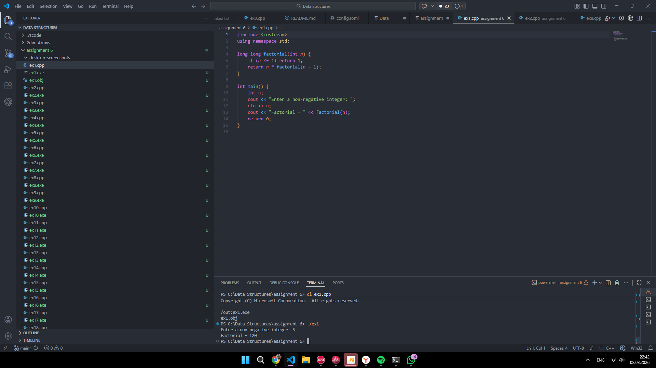
2 | Fibonacci Sequence:  Task: Write a recursive function to generate the nth Fibonacci number.  Example: fibonacci(7) should return 13 (0, 1, 1, 2, 3, 5, 8, 13).  Code (ex2.cpp):  #include <iostream>  using namespace std;  long long fibonacci(int n) {  if (n <= 1) return n;  return fibonacci(n - 1) + fibonacci(n - 2);  }  int main() {  int n;  cout << "Enter n for fibonacci: ";  cin >> n;  cout << "Fibonacci = " << fibonacci(n);  return 0;  }  Screenshot:  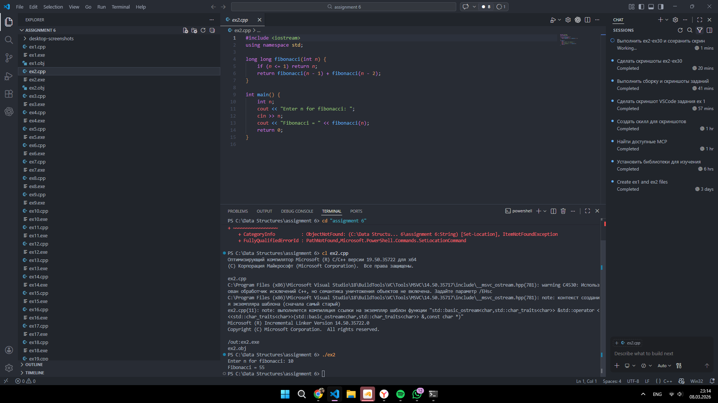
3 | Sum of Digits:  Task: Write a recursive function to calculate the sum of the digits of a given integer.  Example: sumOfDigits(12345) should return 15 (1 + 2 + 3 + 4 + 5).  Code (ex3.cpp):  #include <iostream>  using namespace std;  int sumOfDigits(long long n) {  if (n < 0) n = -n;  if (n == 0) return 0;  return n % 10 + sumOfDigits(n / 10);  }  int main() {  long long n;  cout << "Enter an integer: ";  cin >> n;  cout << "Sum of digits = " << sumOfDigits(n);  return 0;  }  Screenshot:  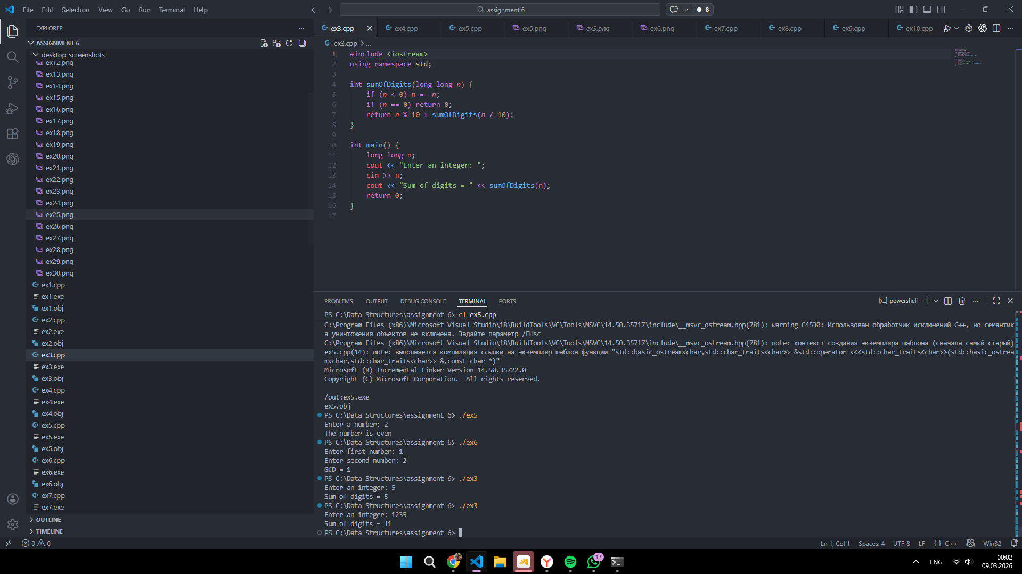
4 | Power Function:  Task: Write a recursive function to calculate x raised to the power of y (x^y).  Example: power(2, 3) should return 8 (2 * 2 * 2).  Code (ex4.cpp):  #include <iostream>  using namespace std;  long long power(long long x, int y) {  if (y == 0) return 1;  return x * power(x, y - 1);  }  int main() {  long long x;  int y;  cout << "Enter base: ";  cin >> x;  cout << "Enter exponent: ";  cin >> y;  cout << "Power = " << power(x, y);  return 0;  }  Screenshot:  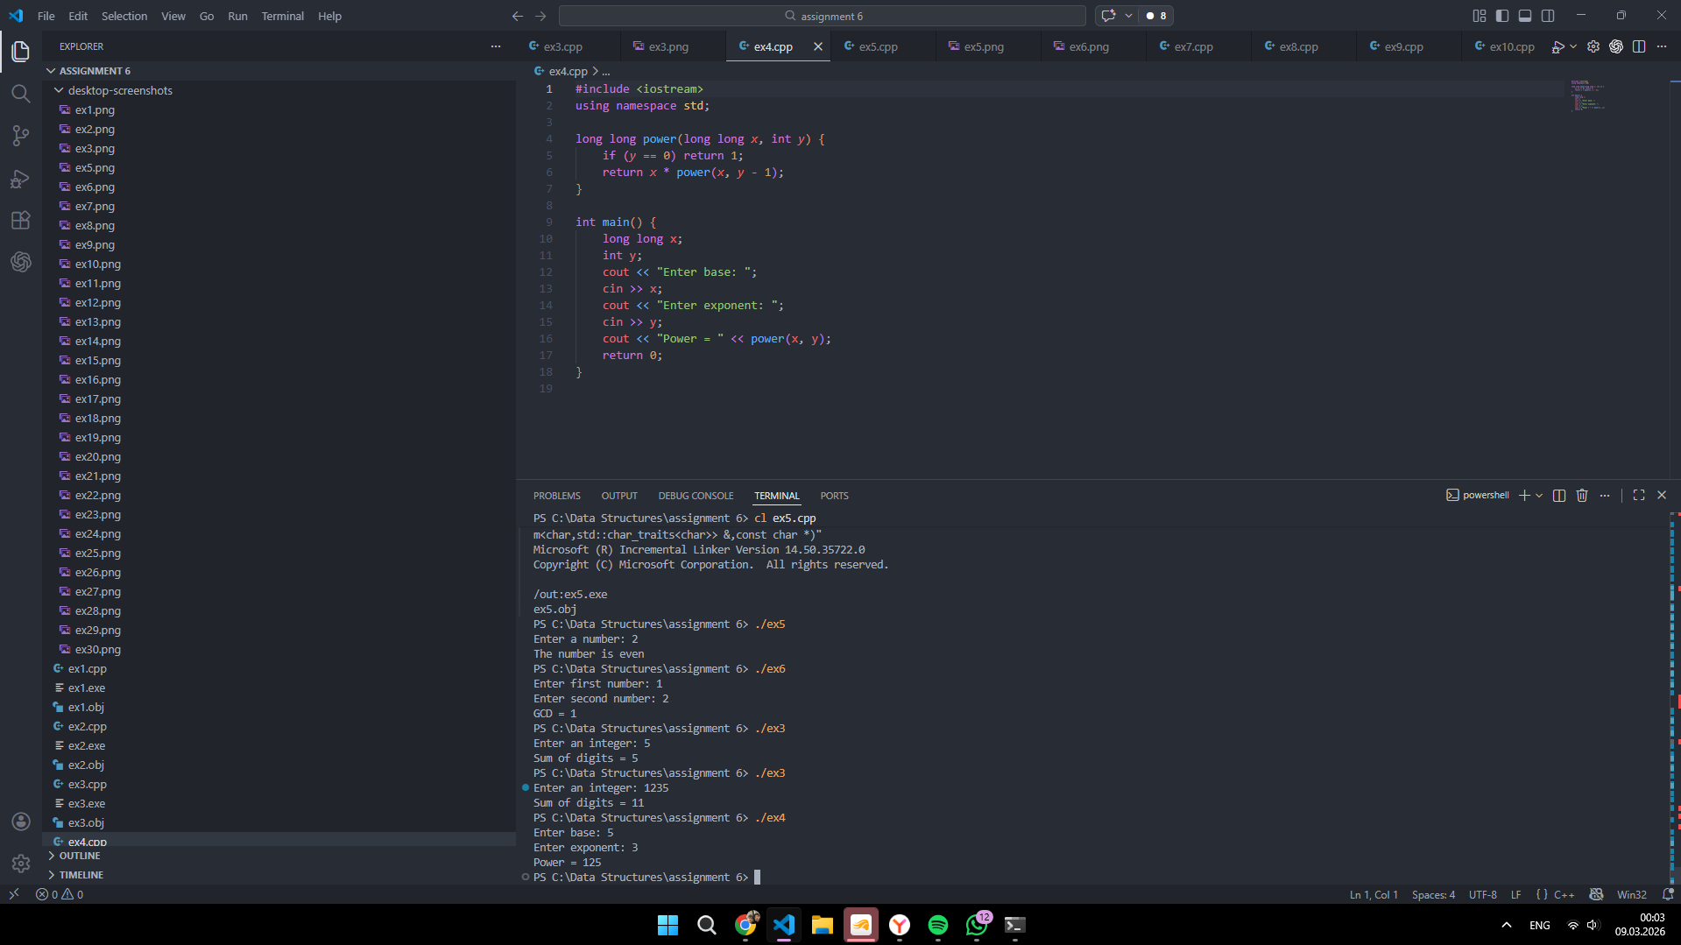
5 | Check if a number is even or odd recursively:  Task: Write a recursive function that checks if a number is even or odd.  Example: checkNum(8) should return “even” (8 4 2 0).  Code (ex5.cpp):  #include <iostream>  #include <string>  using namespace std;  string checkNum(int n) {  if (n < 0) n = -n;  if (n == 0) return "even";  if (n == 1) return "odd";  return checkNum(n - 2);  }  int main() {  int n;  cout << "Enter a number: ";  cin >> n;  cout << "The number is " << checkNum(n);  return 0;  }  Screenshot:  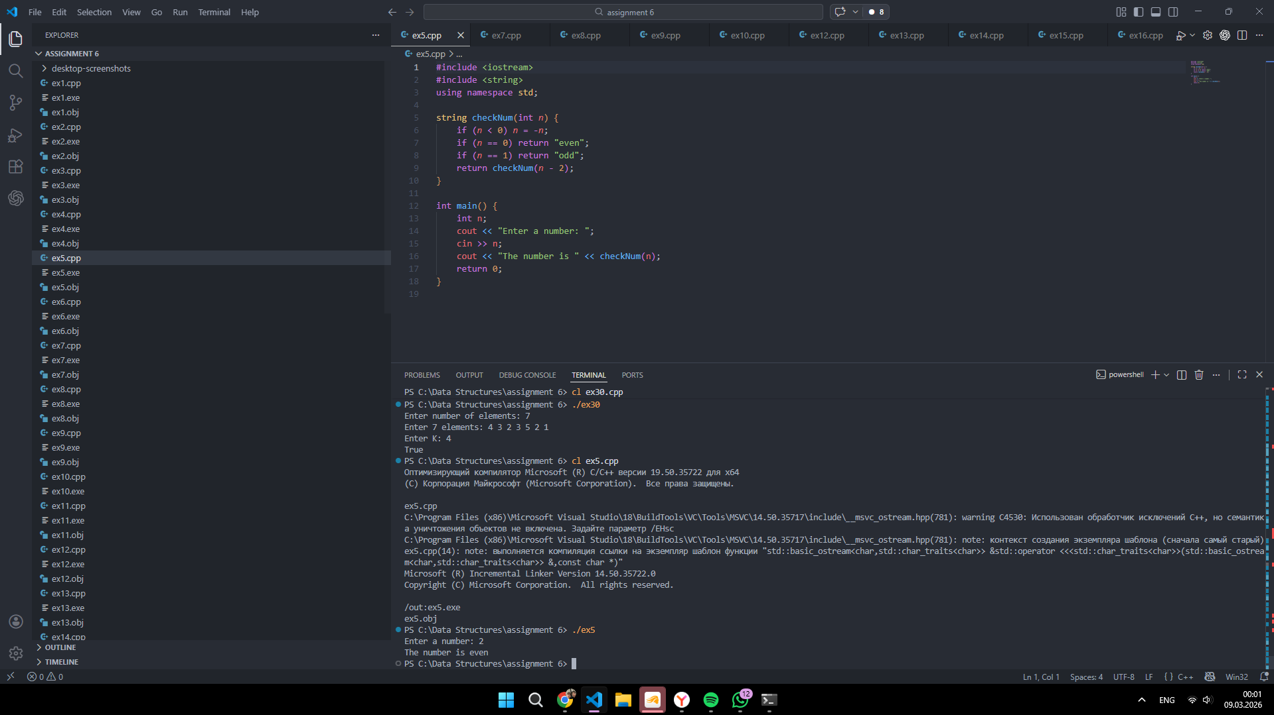
6 | Greatest Common Divisor (GCD) using Euclid's Algorithm:  Task: Implement Euclid's algorithm recursively to find the greatest common divisor of two integers.  Example: gcd(48, 18) should return 6.  Code (ex6.cpp):  #include <iostream>  using namespace std;  int gcdRec(int a, int b) {  if (b == 0) return a < 0 ? -a : a;  return gcdRec(b, a % b);  }  int main() {  int a, b;  cout << "Enter first number: ";  cin >> a;  cout << "Enter second number: ";  cin >> b;  cout << "GCD = " << gcdRec(a, b);  return 0;  }  Screenshot:  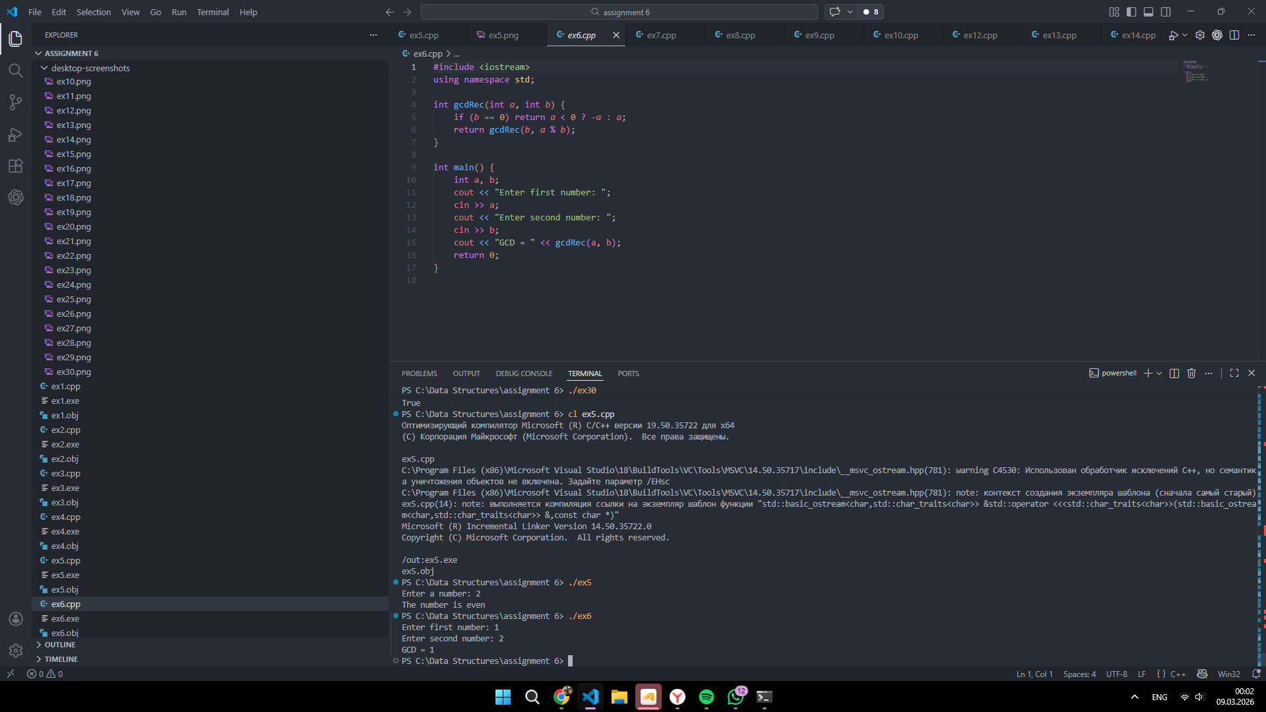
7 | Least Common Multiple (LCM):  Task: Implement a recursive function to compute the LCM of two numbers.  Example: lcm(12, 18) should return 36.  Code (ex7.cpp):  #include <iostream>  using namespace std;  int gcdRec(int a, int b) {  if (b == 0) return a < 0 ? -a : a;  return gcdRec(b, a % b);  }  int lcmRec(int a, int b) {  if (a == 0 || b == 0) return 0;  int g = gcdRec(a, b);  int ans = (a / g) * b;  return ans < 0 ? -ans : ans;  }  int main() {  int a, b;  cout << "Enter first number: ";  cin >> a;  cout << "Enter second number: ";  cin >> b;  cout << "LCM = " << lcmRec(a, b);  return 0;  }  Screenshot:  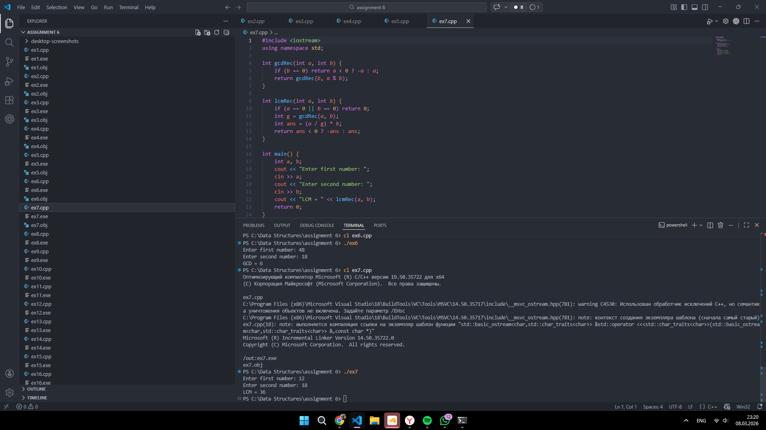
8 | Sum of elements in an array  Task: Write a recursive function to find the sum of elements in an array.  Example: sumOfElements(arr, 5) arr{1,2,3,4,5} should return 15.  Code (ex8.cpp):  #include <iostream>  #include <vector>  using namespace std;  int sumArray(const vector<int>& arr, int n) {  if (n == 0) return 0;  return arr[n - 1] + sumArray(arr, n - 1);  }  int main() {  int n;  cout << "Enter array size: ";  cin >> n;  vector<int> arr(n);  cout << "Enter " << n << " elements: ";  for (int i = 0; i < n; i++) cin >> arr[i];  cout << "Sum = " << sumArray(arr, n);  return 0;  }  Screenshot:  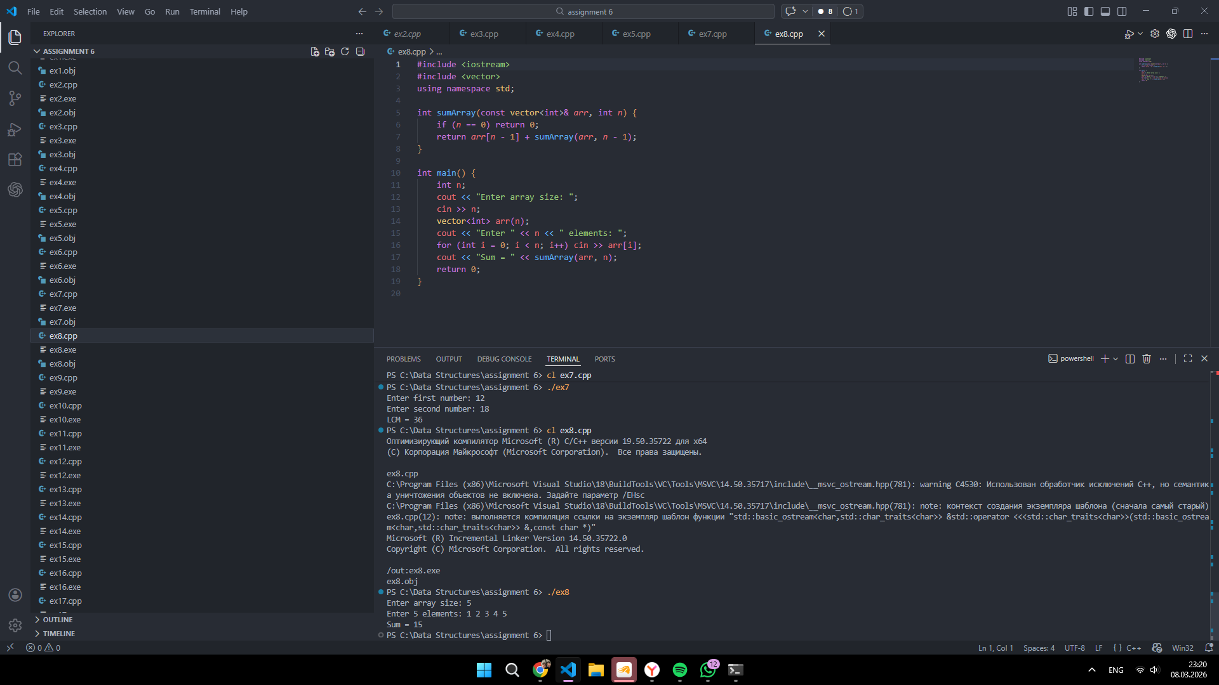
9 | Convert a number to binary recursively  Task: Implement a recursive function to find the binary representation of a number.  Example: convertToBinary(5) should return 101.  Code (ex9.cpp):  #include <iostream>  using namespace std;  void convertToBinary(int n) {  if (n <= 1) {  cout << n;  return;  }  convertToBinary(n / 2);  cout << n % 2;  }  int main() {  int n;  cout << "Enter a non-negative number: ";  cin >> n;  cout << "Binary = ";  convertToBinary(n);  return 0;  }  Screenshot:  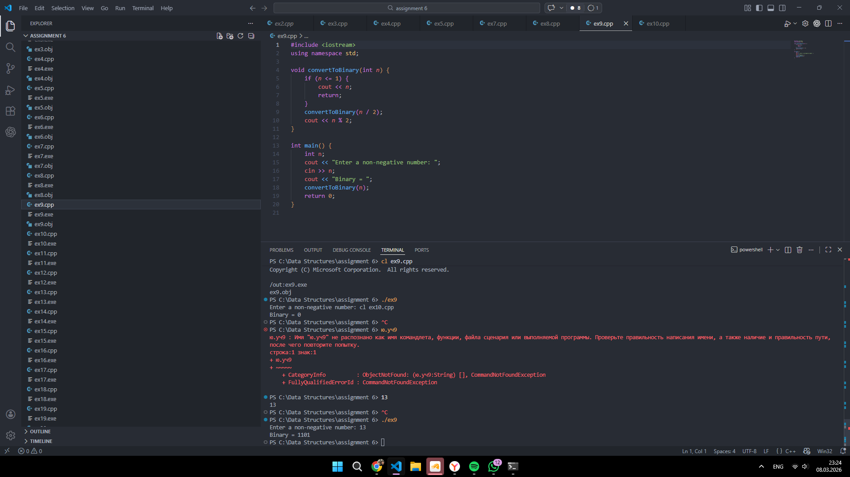
10 | Check if a number is prime  Task: Implement a recursive function to determine if a number is prime.  Example: isPrime(113) should return True.  Code (ex10.cpp):  #include <iostream>  using namespace std;  bool isPrimeRec(int n, int d) {  if (n < 2) return false;  if (d * d > n) return true;  if (n % d == 0) return false;  return isPrimeRec(n, d + 1);  }  int main() {  int n;  cout << "Enter a number: ";  cin >> n;  cout << (isPrimeRec(n, 2) ? "Prime" : "Not prime");  return 0;  }  Screenshot:  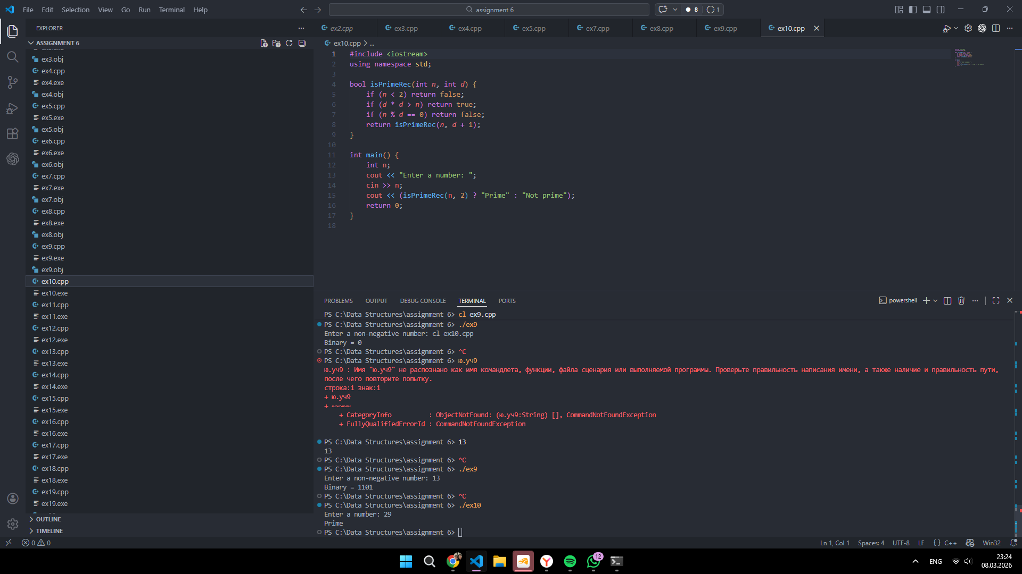
11 | Multiply two numbers using recursion  Task: Write a recursive function to multiply two numbers without using *.  Example: multiplyRecursive(5, 3) should return 15.  Code (ex11.cpp):  #include <iostream>  using namespace std;  int multiplyRec(int a, int b) {  if (b == 0) return 0;  if (b < 0) return -multiplyRec(a, -b);  return a + multiplyRec(a, b - 1);  }  int main() {  int a, b;  cout << "Enter first number: ";  cin >> a;  cout << "Enter second number: ";  cin >> b;  cout << "Result = " << multiplyRec(a, b);  return 0;  }  Screenshot:  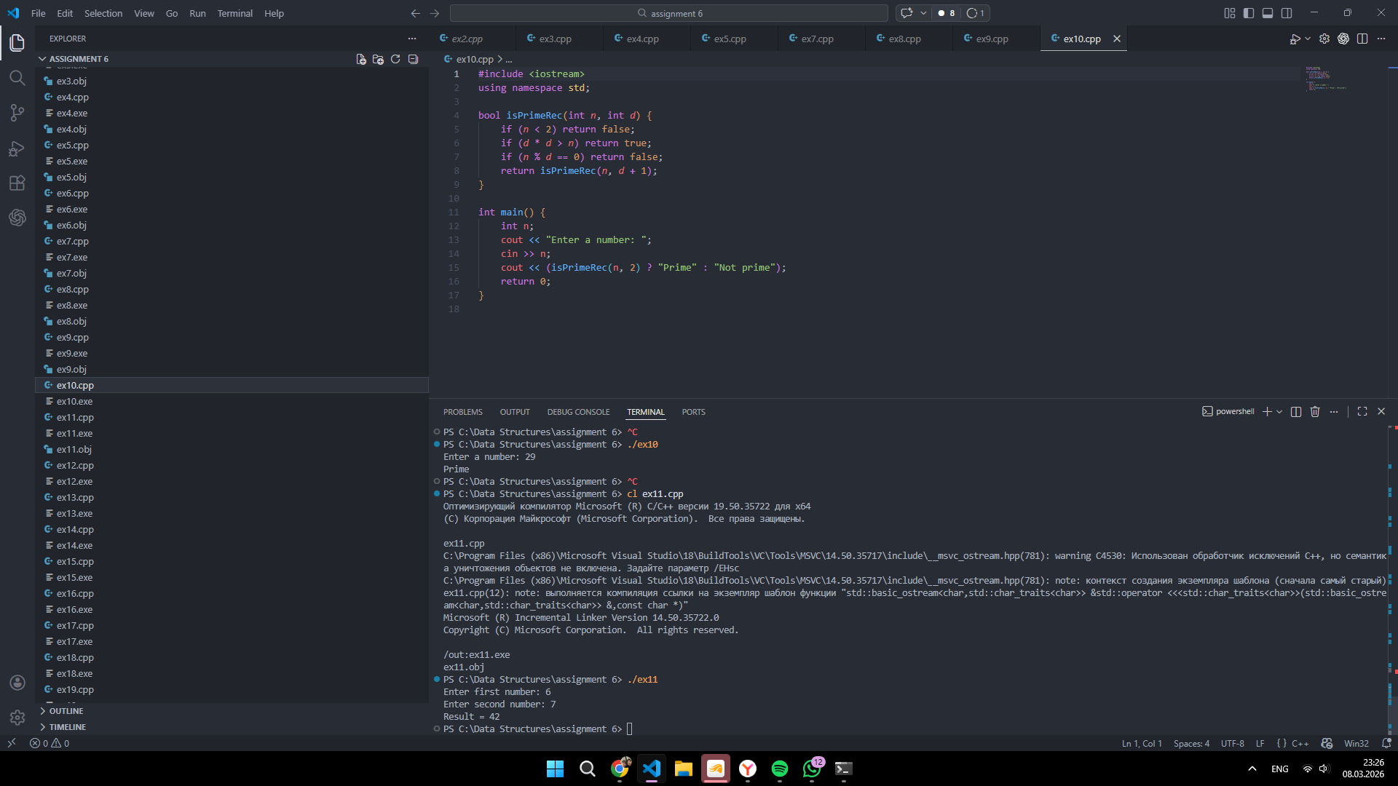
12 | Find the length of an array recursively  Task: Write a recursive function to determine the length of an array.  Example: arrayLength(arr, 10) arr{1, 2, 3, 4, 5} should return 5.  Code (ex12.cpp):  #include <iostream>  #include <vector>  using namespace std;  int arrayLength(const vector<int>& arr, int index) {  if (index == (int)arr.size()) return 0;  return 1 + arrayLength(arr, index + 1);  }  int main() {  int n;  cout << "Enter array size: ";  cin >> n;  vector<int> arr(n);  cout << "Enter " << n << " elements: ";  for (int i = 0; i < n; i++) cin >> arr[i];  cout << "Length = " << arrayLength(arr, 0);  return 0;  }  Screenshot:  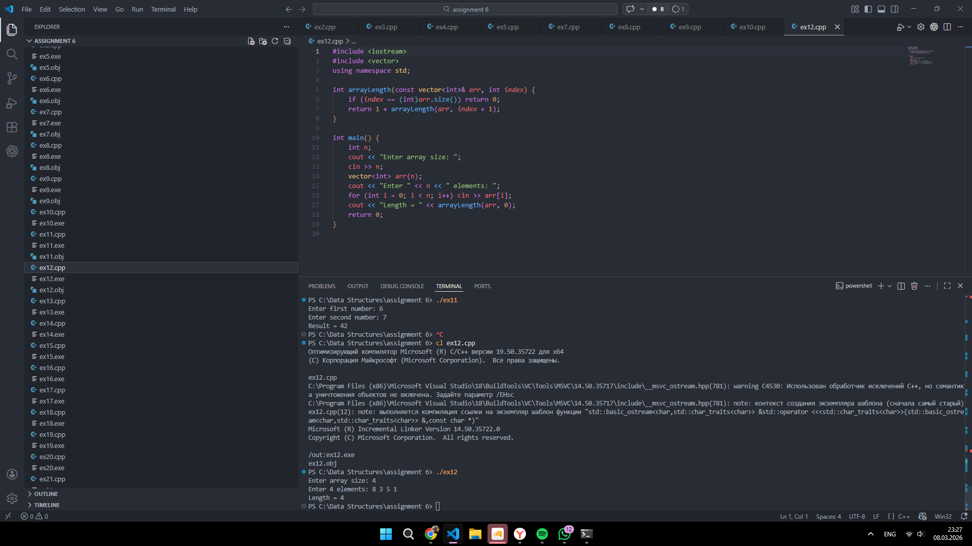
13 | Find Minimum Element in an Array  Task: Write a recursive function to find the smallest element in an array.  Example: findMin(arr, 5) arr{5, 4, 3, 1, 2} should return 1.  Code (ex13.cpp):  #include <iostream>  #include <vector>  using namespace std;  int findMinRec(const vector<int>& arr, int n) {  if (n == 1) return arr[0];  int m = findMinRec(arr, n - 1);  return arr[n - 1] < m ? arr[n - 1] : m;  }  int main() {  int n;  cout << "Enter array size: ";  cin >> n;  vector<int> arr(n);  cout << "Enter " << n << " elements: ";  for (int i = 0; i < n; i++) cin >> arr[i];  cout << "Minimum = " << findMinRec(arr, n);  return 0;  }  Screenshot:  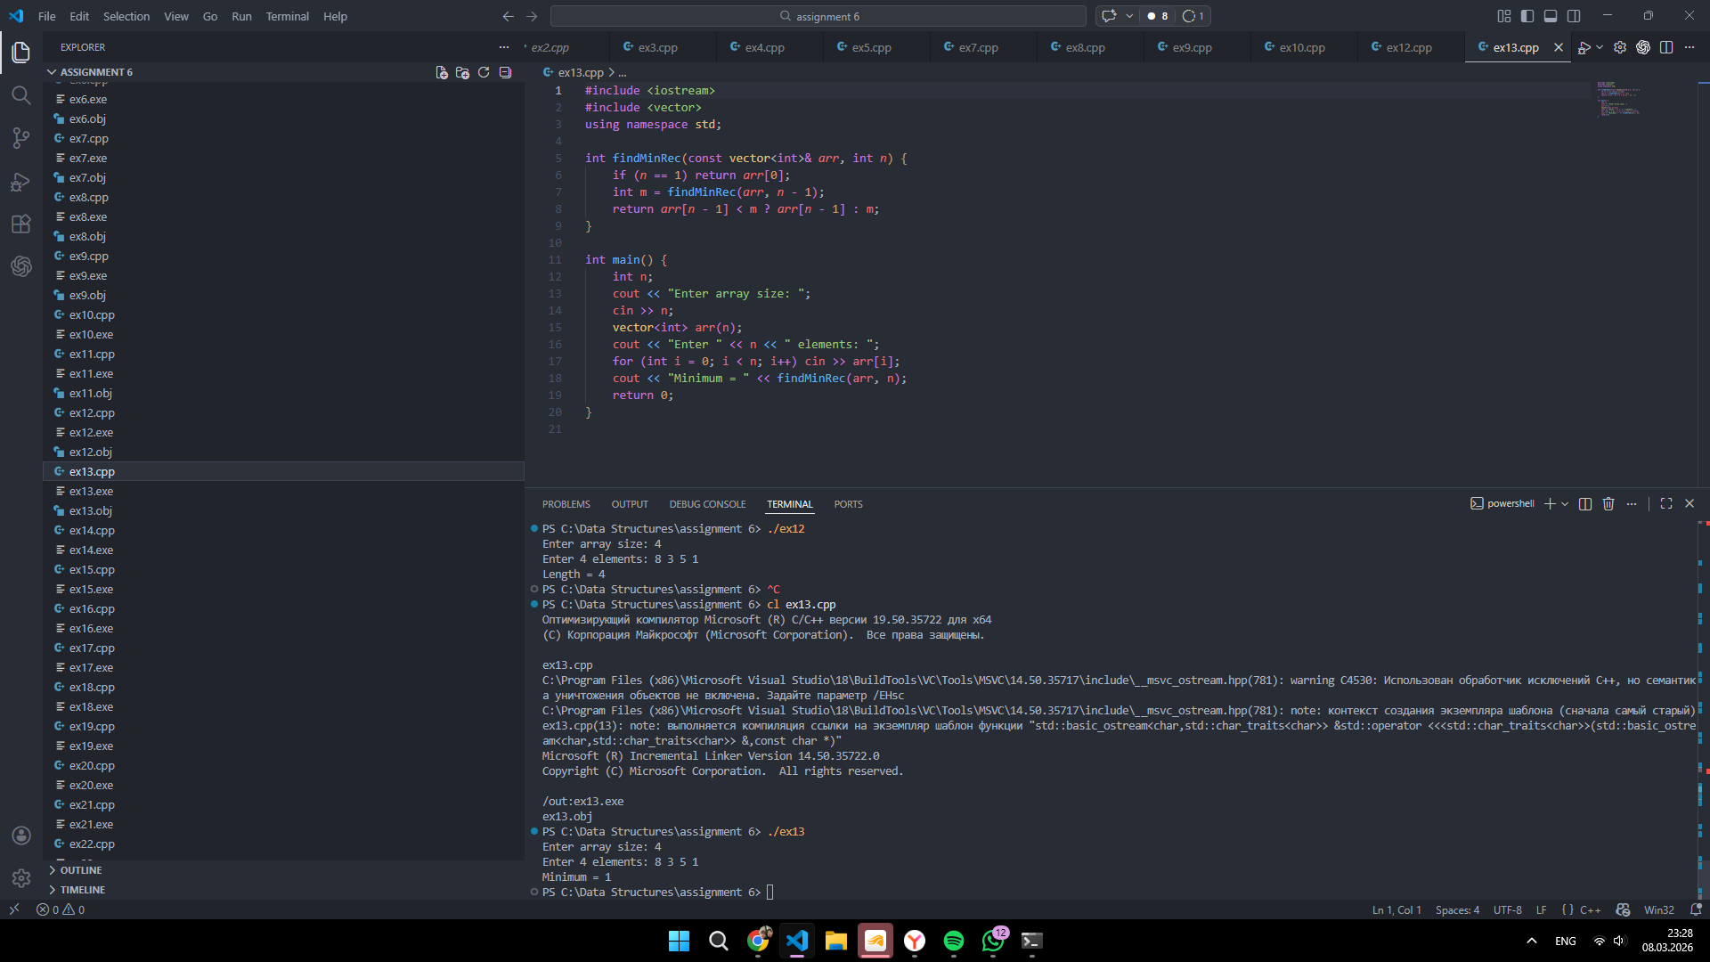
14 | Check if an Array is Sorted  Task: Implement a recursive function to check whether a given array is sorted in ascending order.  Example: isSorted(arr, 5) arr{1, 2, 3, 5, 4} should return False.  Code (ex14.cpp):  #include <iostream>  #include <vector>  using namespace std;  bool isSortedRec(const vector<int>& arr, int i) {  if (i >= (int)arr.size() - 1) return true;  if (arr[i] > arr[i + 1]) return false;  return isSortedRec(arr, i + 1);  }  int main() {  int n;  cout << "Enter array size: ";  cin >> n;  vector<int> arr(n);  cout << "Enter " << n << " elements: ";  for (int i = 0; i < n; i++) cin >> arr[i];  cout << (isSortedRec(arr, 0) ? "Sorted" : "Not sorted");  return 0;  }  Screenshot:  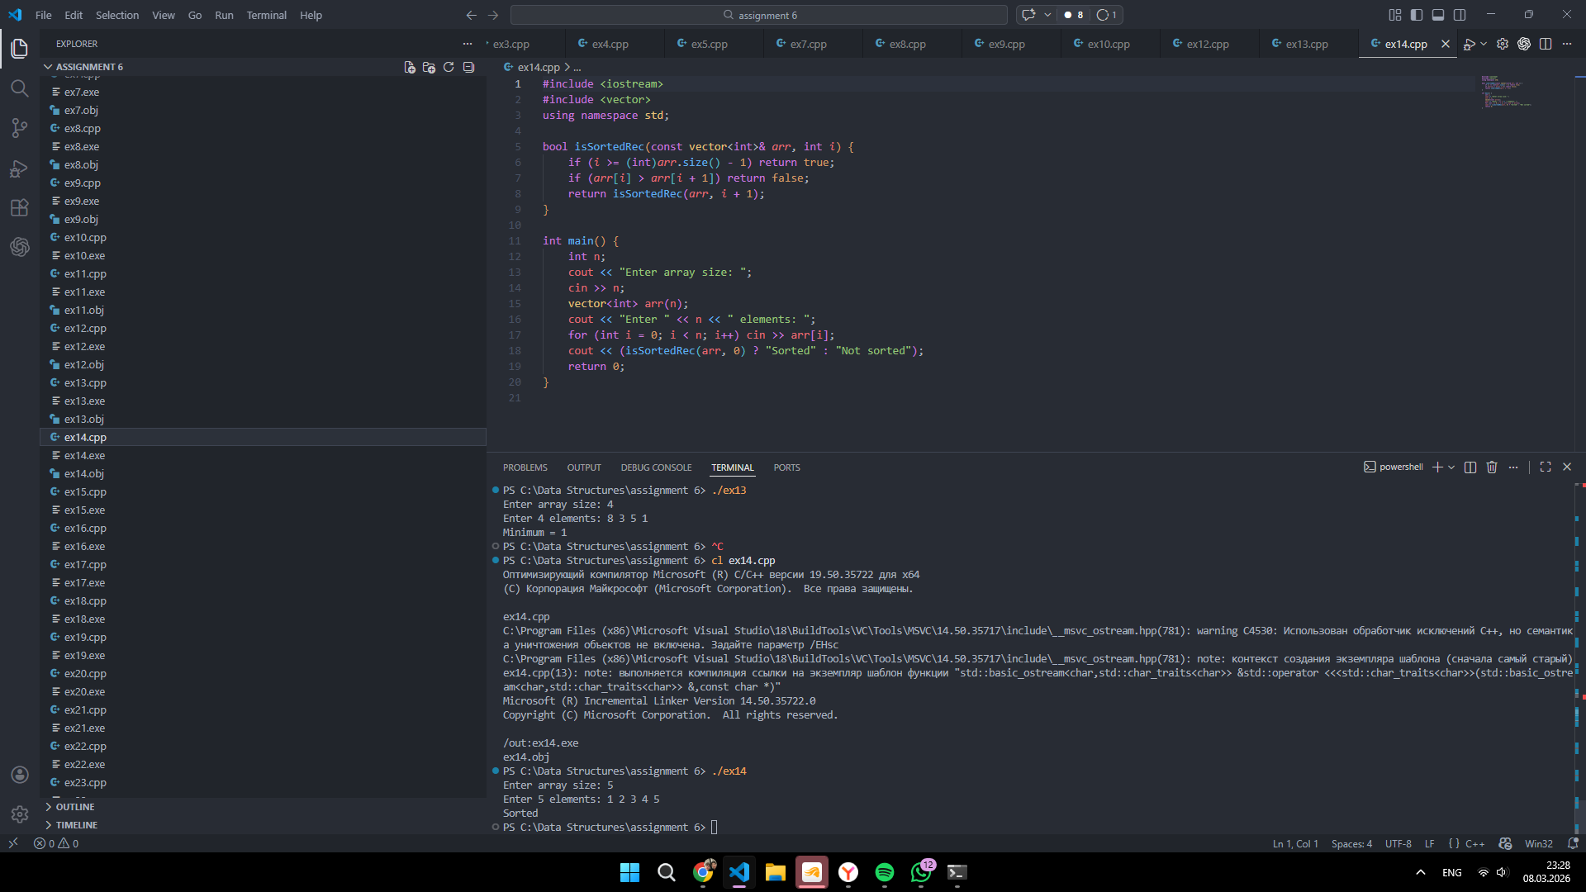
15 | Print a Number in Reverse Order  Task: Implement a recursive function to print the digits of a number in reverse order.  Example: reverseDigits(7712345) should return 5432177.  Code (ex15.cpp):  #include <iostream>  using namespace std;  void reverseDigits(long long n) {  if (n < 10) {  cout << n;  return;  }  cout << n % 10;  reverseDigits(n / 10);  }  int main() {  long long n;  cout << "Enter a number: ";  cin >> n;  cout << "Reversed digits = ";  if (n < 0) {  cout << "-";  n = -n;  }  reverseDigits(n);  return 0;  }  Screenshot:  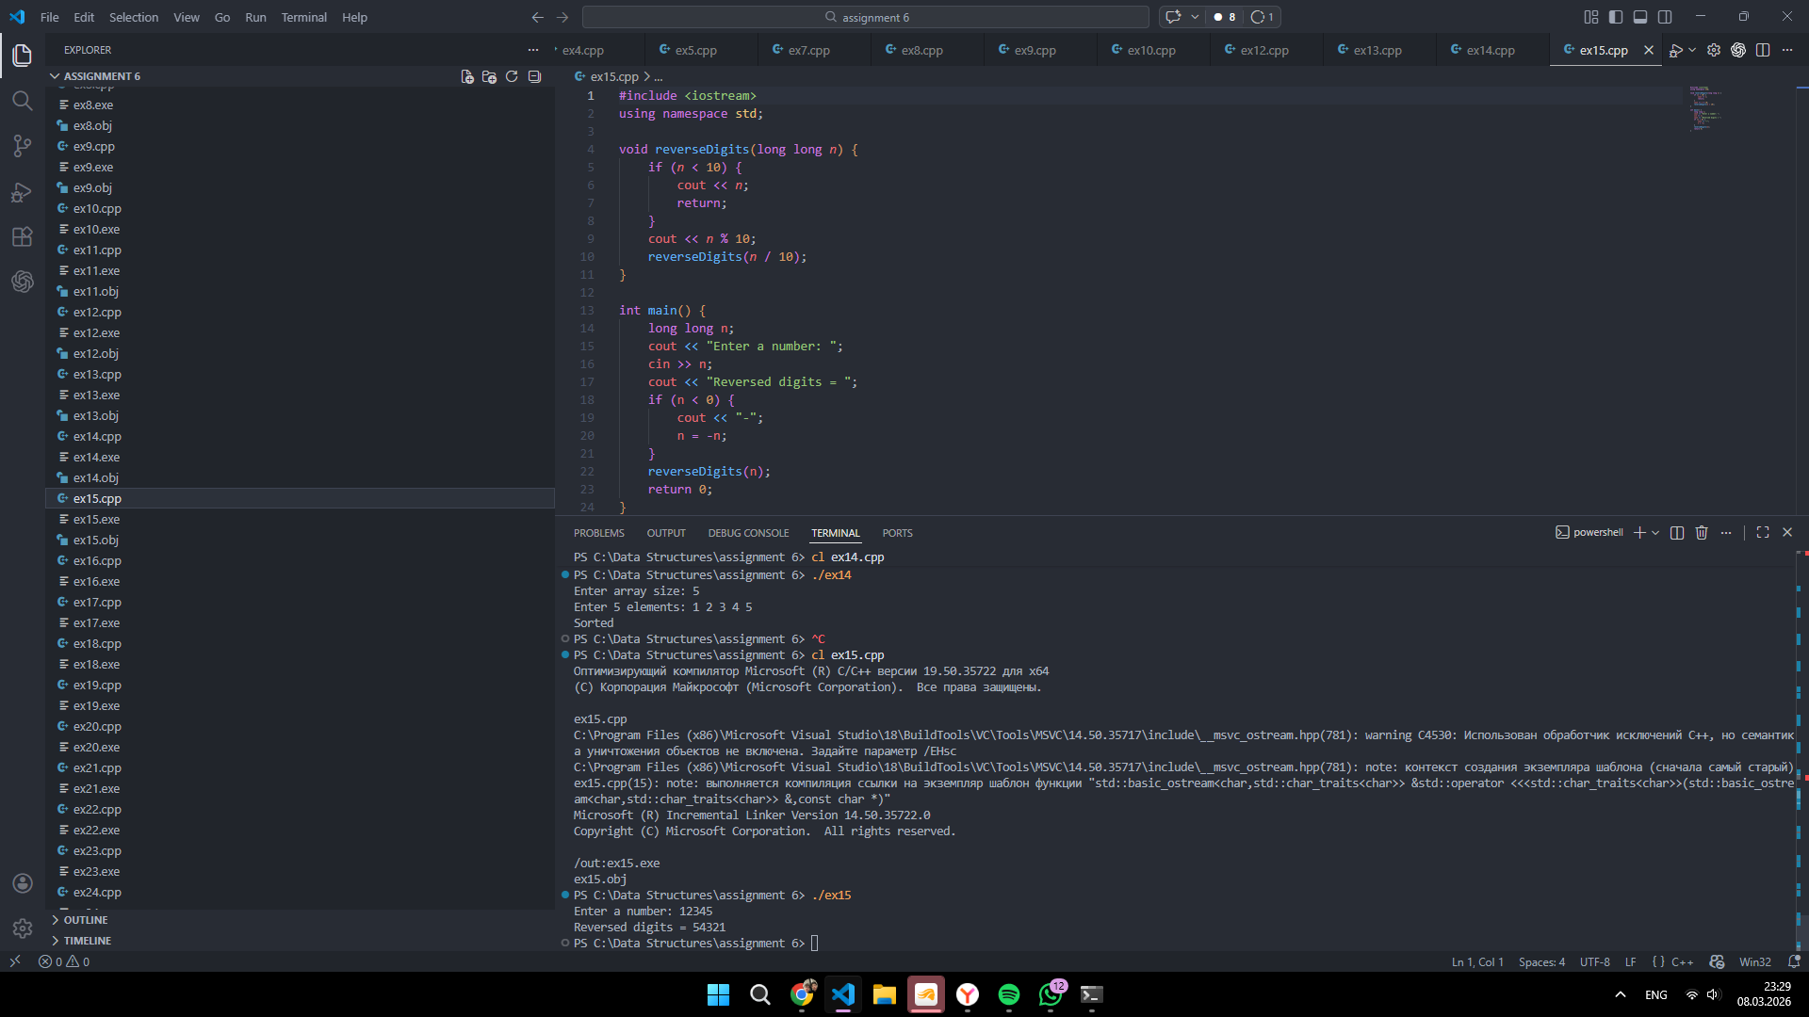
16 | Count occurrences of a character in a string  Task: Write a recursive function that counts the occurrences of a given character in a string.  Example: countOccurences("initialization", ‘i’) should return 5.  Code (ex16.cpp):  #include <iostream>  #include <string>  using namespace std;  int countChar(const string& s, char ch, int i) {  if (i == (int)s.size()) return 0;  return (s[i] == ch) + countChar(s, ch, i + 1);  }  int main() {  string s;  char ch;  cout << "Enter a string: ";  getline(cin, s);  cout << "Enter a character: ";  cin >> ch;  cout << "Occurrences = " << countChar(s, ch, 0);  return 0;  }  Screenshot:  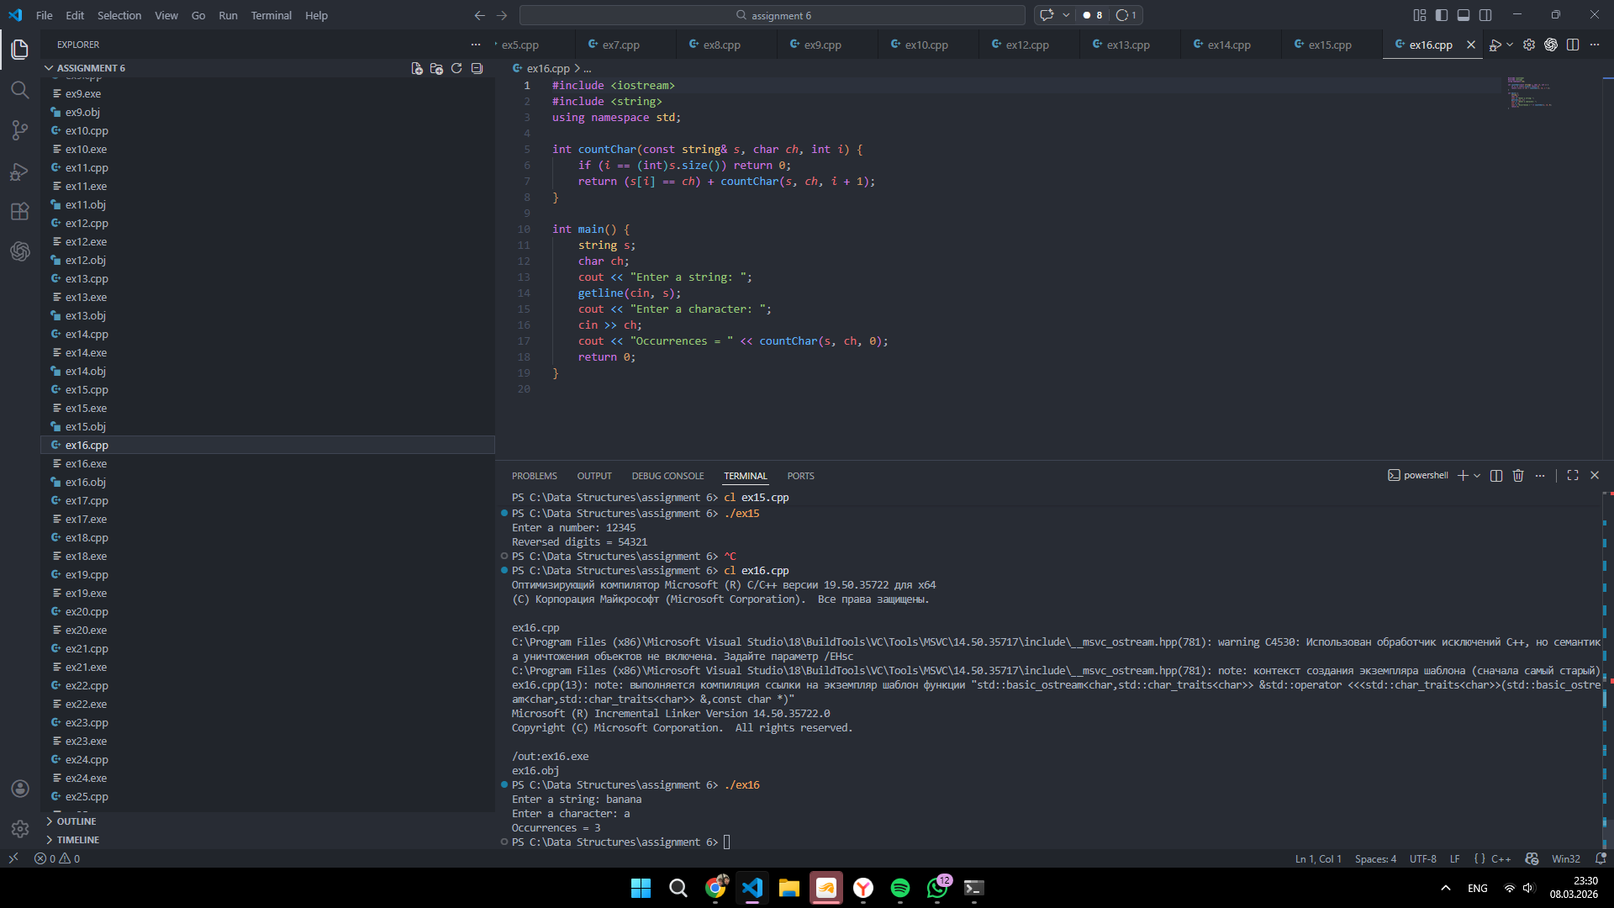
17 | String Reversal:  Task: Write a recursive function to reverse a given string.  Example: reverseString("hello") should return "olleh".  Code (ex17.cpp):  #include <iostream>  #include <string>  using namespace std;  string reverseString(const string& s) {  if (s.empty()) return "";  return reverseString(s.substr(1)) + s[0];  }  int main() {  string s;  cout << "Enter a string: ";  getline(cin, s);  cout << "Reversed string = " << reverseString(s);  return 0;  }  Screenshot:  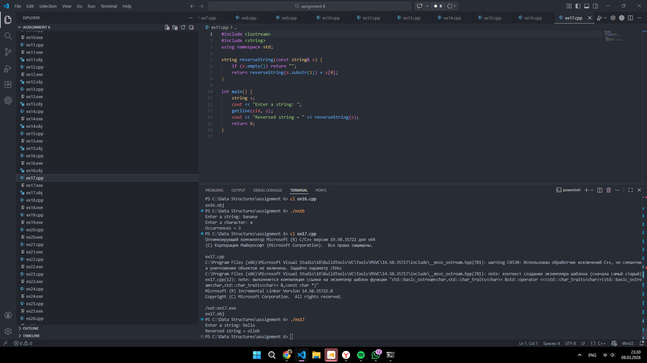
18 | Palindrome Check (Recursive):  Task: Write a recursive function to check if a string is a palindrome (reads the same forwards and backward). Ignore spaces and case.  Example: isPalindrome("Racecar") should return true.  Code (ex18.cpp):  #include <iostream>  #include <string>  #include <cctype>  using namespace std;  bool isPalindromeRec(const string& s, int l, int r) {  if (l >= r) return true;  if (s[l] != s[r]) return false;  return isPalindromeRec(s, l + 1, r - 1);  }  int main() {  string s, clean;  cout << "Enter a string: ";  getline(cin, s);  for (char c : s) {  if (c != ' ') clean += (char)tolower((unsigned char)c);  }  cout << (isPalindromeRec(clean, 0, (int)clean.size() - 1) ? "Palindrome" : "Not palindrome");  return 0;  }  Screenshot:  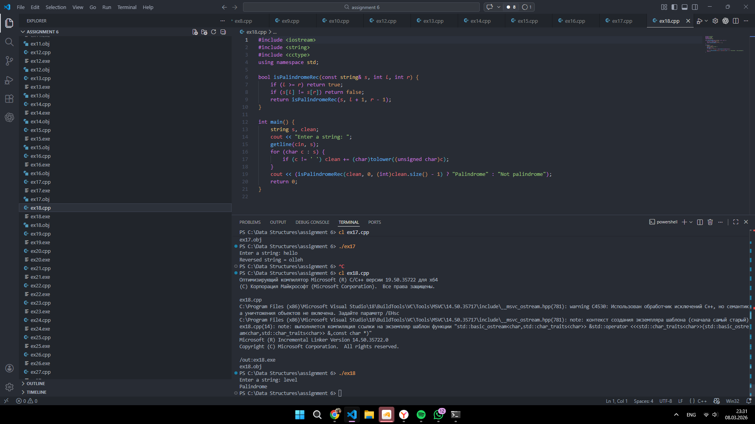
19 | Generate All Subsets of a String  Task: Implement a recursive function that prints all subsets (subsequences) of a given string.  Example: generateSubsets ("abc") should return "", "a", "b", "c", "ab", "ac", "bc", "abc".  Code (ex19.cpp):  #include <iostream>  #include <string>  using namespace std;  void generateSubsets(const string& s, int i, string current) {  if (i == (int)s.size()) {  cout << "\"" << current << "\"" << endl;  return;  }  generateSubsets(s, i + 1, current);  generateSubsets(s, i + 1, current + s[i]);  }  int main() {  string s;  cout << "Enter a string: ";  getline(cin, s);  cout << "Subsets:" << endl;  generateSubsets(s, 0, "");  return 0;  }  Screenshot:  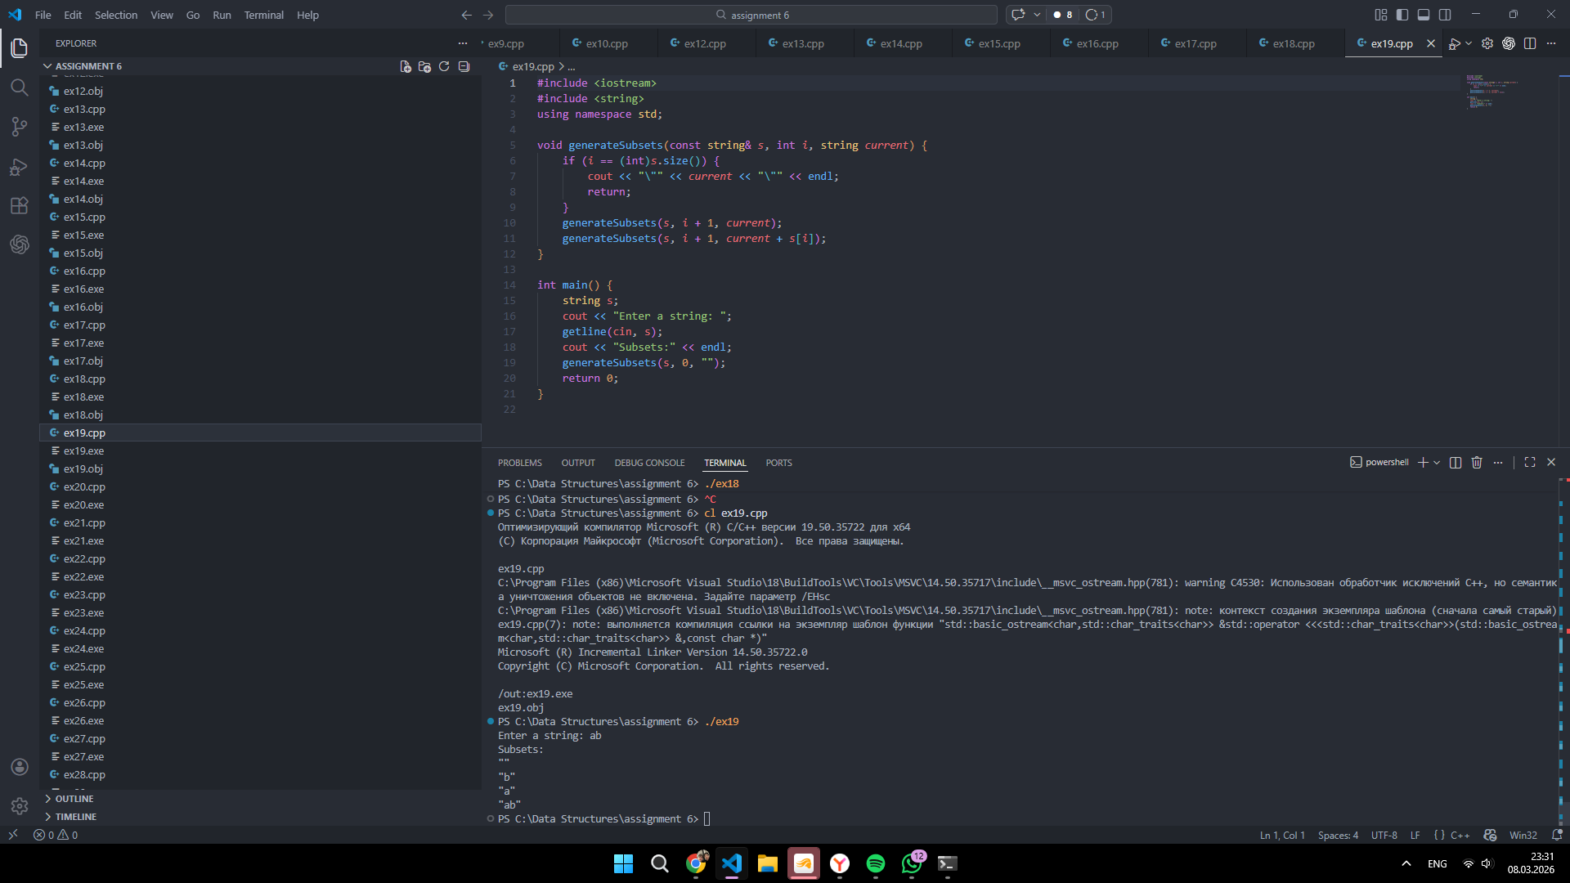
20 | Print All Permutations of a String  Task: Write a recursive function to print all possible permutations of a given string.  Example: generatePermutations ("abc") should return: abc acb bac bca cab cba.  Code (ex20.cpp):  #include <iostream>  #include <string>  using namespace std;  void swapChar(char& a, char& b) {  char t = a;  a = b;  b = t;  }  void permutations(string& s, int i) {  if (i == (int)s.size()) {  cout << s << endl;  return;  }  for (int j = i; j < (int)s.size(); j++) {  swapChar(s[i], s[j]);  permutations(s, i + 1);  swapChar(s[i], s[j]);  }  }  int main() {  string s;  cout << "Enter a string: ";  getline(cin, s);  cout << "Permutations:" << endl;  permutations(s, 0);  return 0;  }  Screenshot:  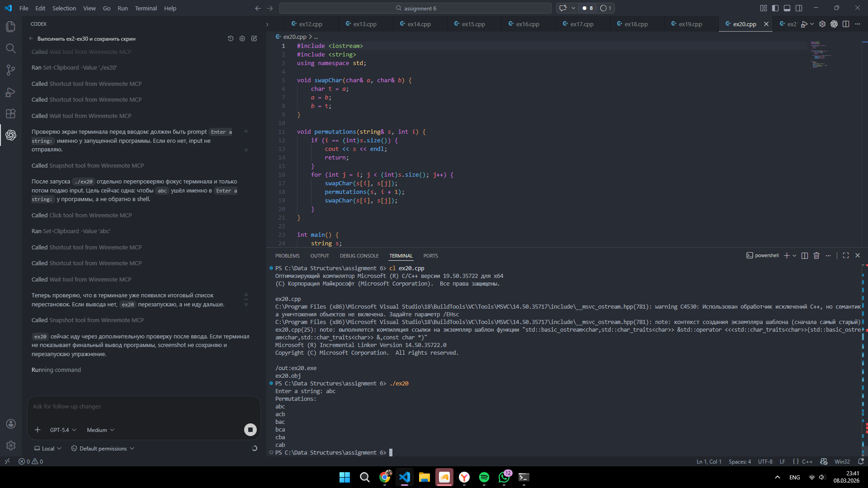

Part B “Backtracking” (10 exercises)
№ | Task
1 | String Permutations  Task: Write a function that takes a string and returns all possible rearrangements of its characters.  - Example: permute("ABC") should return ["ABC", "ACB", "BAC", "BCA", "CAB", "CBA"].  Code (ex21.cpp):  #include <iostream>  #include <string>  #include <vector>  using namespace std;  void permute(string& s, int i, vector<string>& ans) {  if (i == (int)s.size()) {  ans.push_back(s);  return;  }  for (int j = i; j < (int)s.size(); j++) {  swap(s[i], s[j]);  permute(s, i + 1, ans);  swap(s[i], s[j]);  }  }  int main() {  string s;  vector<string> ans;  cout << "Enter a string: ";  getline(cin, s);  permute(s, 0, ans);  cout << "All permutations:" << endl;  for (string x : ans) cout << x << endl;  return 0;  }  Screenshot:  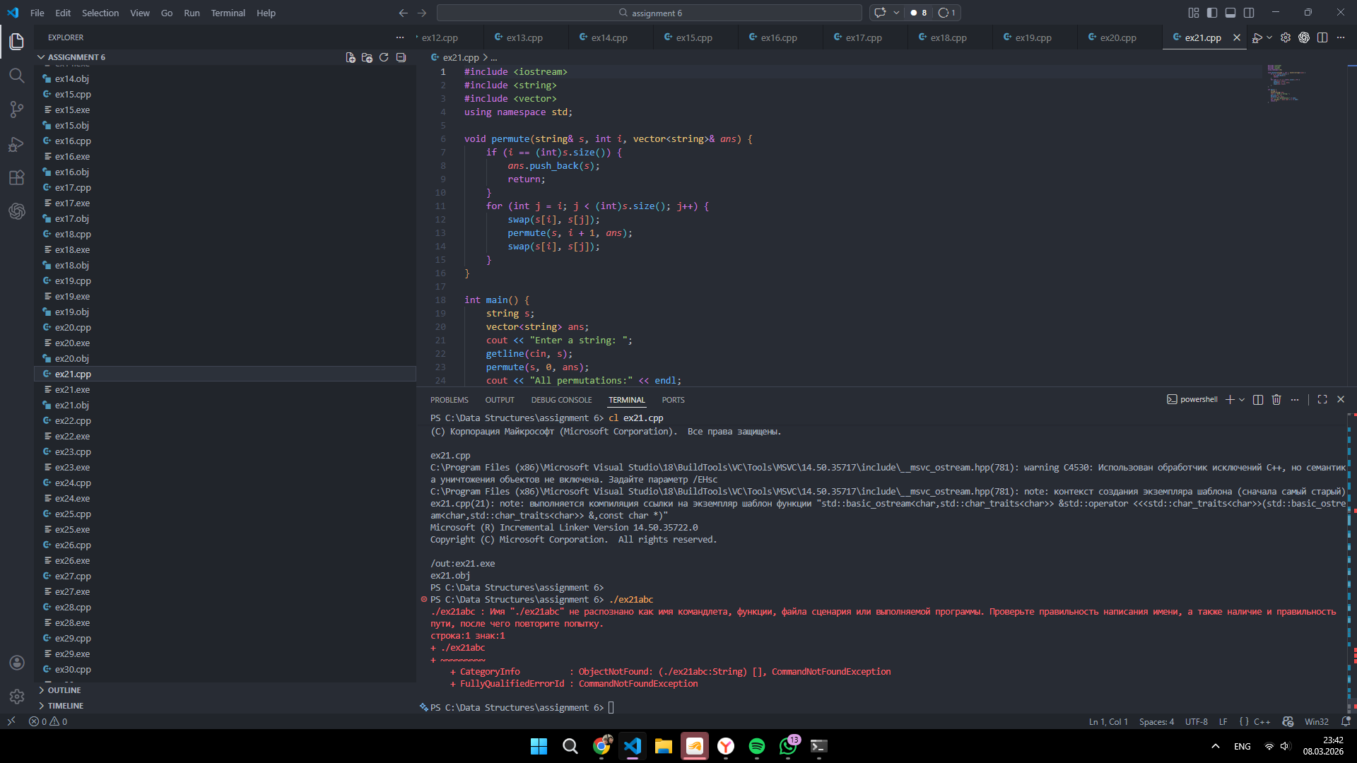
2 | The Subset Sum Problem  Task: Given a set of distinct integers and a target number, find all unique combinations of numbers that add up to the target.  - Example: For set {10, 1, 2, 7, 6, 1, 5} and target 8, one subset is {1, 2, 5}.  Code (ex22.cpp):  #include <iostream>  #include <vector>  #include <algorithm>  using namespace std;  void subsetSum(vector<int>& arr, int target, int index, vector<int>& current, vector<vector<int>>& ans) {  if (target == 0) {  ans.push_back(current);  return;  }  for (int i = index; i < (int)arr.size(); i++) {  if (i > index && arr[i] == arr[i - 1]) continue;  if (arr[i] > target) break;  current.push_back(arr[i]);  subsetSum(arr, target - arr[i], i + 1, current, ans);  current.pop_back();  }  }  int main() {  int n, target;  cout << "Enter number of elements: ";  cin >> n;  vector<int> arr(n);  cout << "Enter " << n << " elements: ";  for (int i = 0; i < n; i++) cin >> arr[i];  cout << "Enter target sum: ";  cin >> target;  sort(arr.begin(), arr.end());  vector<int> current;  vector<vector<int>> ans;  subsetSum(arr, target, 0, current, ans);  cout << "Subsets:" << endl;  for (auto v : ans) {  for (int x : v) cout << x << " ";  cout << endl;  }  return 0;  }  Screenshot:  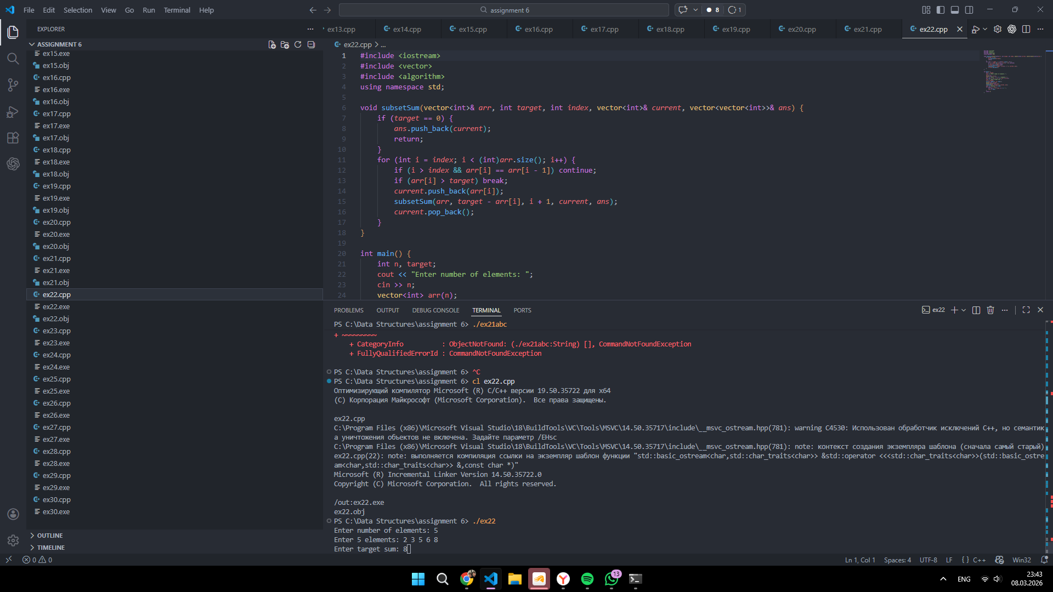
3 | Palindrome Partitioning  Task: Given a string, partition it such that every substring of the partition is a palindrome. Return all possible combinations.  Example: partition("aab") returns [["a","a","b"], ["aa","b"]].  Code (ex23.cpp):  #include <iostream>  #include <string>  #include <vector>  using namespace std;  bool isPal(const string& s, int l, int r) {  while (l < r) {  if (s[l] != s[r]) return false;  l++;  r--;  }  return true;  }  void partitionString(const string& s, int start, vector<string>& current, vector<vector<string>>& ans) {  if (start == (int)s.size()) {  ans.push_back(current);  return;  }  for (int end = start; end < (int)s.size(); end++) {  if (isPal(s, start, end)) {  current.push_back(s.substr(start, end - start + 1));  partitionString(s, end + 1, current, ans);  current.pop_back();  }  }  }  int main() {  string s;  cout << "Enter a string: ";  getline(cin, s);  vector<string> current;  vector<vector<string>> ans;  partitionString(s, 0, current, ans);  cout << "Palindrome partitions:" << endl;  for (auto part : ans) {  for (string x : part) cout << x << " ";  cout << endl;  }  return 0;  }  Screenshot:  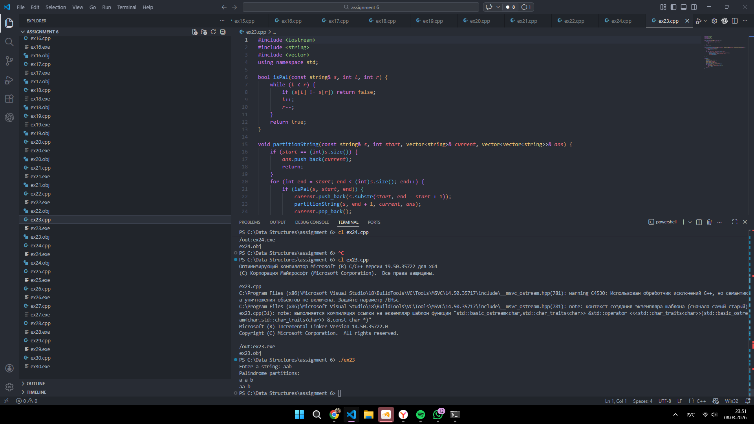
4 | Combinations of a Phone Number  Task: Given a string containing digits from 2–9 (like old T9 texting), return all possible letter combinations that the number could represent.  Example: 2 is "abc", 3 is "def". combine("23") returns ["ad", "ae", "af", "bd", "be", "bf", "cd", "ce", "cf"].  Code (ex24.cpp):  #include <iostream>  #include <string>  #include <vector>  using namespace std;  string mp[10] = {"", "", "abc", "def", "ghi", "jkl", "mno", "pqrs", "tuv", "wxyz"};  void phoneComb(const string& digits, int i, string current, vector<string>& ans) {  if (i == (int)digits.size()) {  if (!current.empty()) ans.push_back(current);  return;  }  string letters = mp[digits[i] - '0'];  for (char c : letters) phoneComb(digits, i + 1, current + c, ans);  }  int main() {  string digits;  cout << "Enter digits from 2 to 9: ";  cin >> digits;  vector<string> ans;  phoneComb(digits, 0, "", ans);  cout << "Combinations:" << endl;  for (string x : ans) cout << x << endl;  return 0;  }  Screenshot:  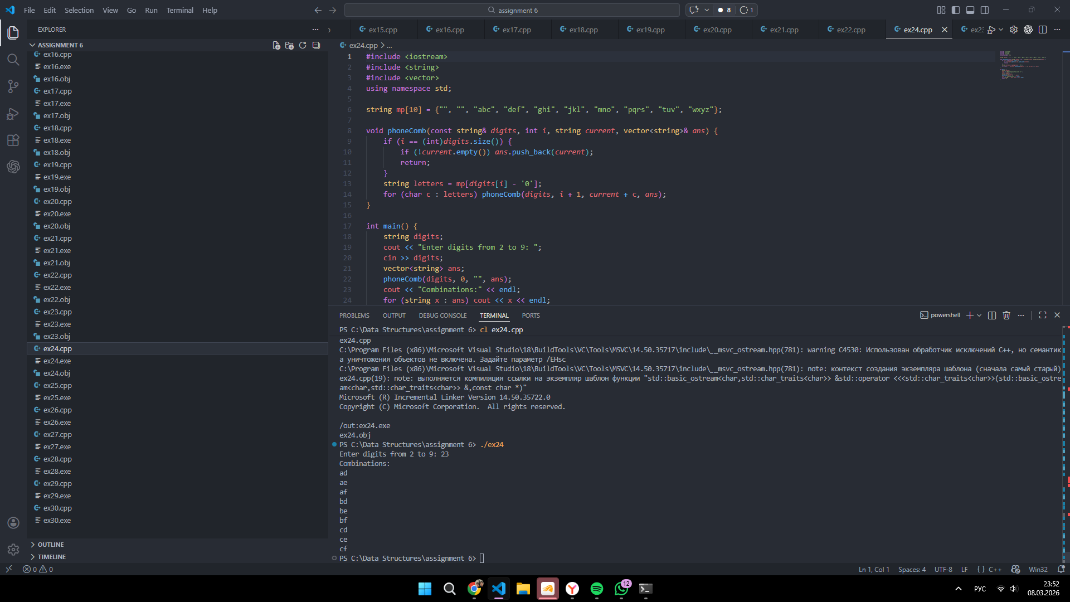
5 | Word Search  Task: Given a 2D board of letters and a word, determine if the word exists in the grid. The word can be constructed from letters of sequentially adjacent cells (horizontal or vertical).  Example: Board [['A','B'],['C','D']], Word "ABD" returns true.  Code (ex25.cpp):  #include <iostream>  #include <vector>  #include <string>  using namespace std;  bool searchWord(vector<string>& board, string& word, int r, int c, int index) {  if (index == (int)word.size()) return true;  if (r < 0 || c < 0 || r >= (int)board.size() || c >= (int)board[0].size()) return false;  if (board[r][c] != word[index]) return false;  char temp = board[r][c];  board[r][c] = '#';  bool found = searchWord(board, word, r + 1, c, index + 1) ||  searchWord(board, word, r - 1, c, index + 1) ||  searchWord(board, word, r, c + 1, index + 1) ||  searchWord(board, word, r, c - 1, index + 1);  board[r][c] = temp;  return found;  }  int main() {  int rows, cols;  cout << "Enter number of rows: ";  cin >> rows;  cout << "Enter number of columns: ";  cin >> cols;  vector<string> board(rows);  cout << "Enter the board rows:" << endl;  for (int i = 0; i < rows; i++) cin >> board[i];  string word;  cout << "Enter the word to search: ";  cin >> word;  bool found = false;  for (int i = 0; i < rows; i++) {  for (int j = 0; j < cols; j++) {  if (searchWord(board, word, i, j, 0)) found = true;  }  }  cout << (found ? "Word found" : "Word not found");  return 0;  }  Screenshot:  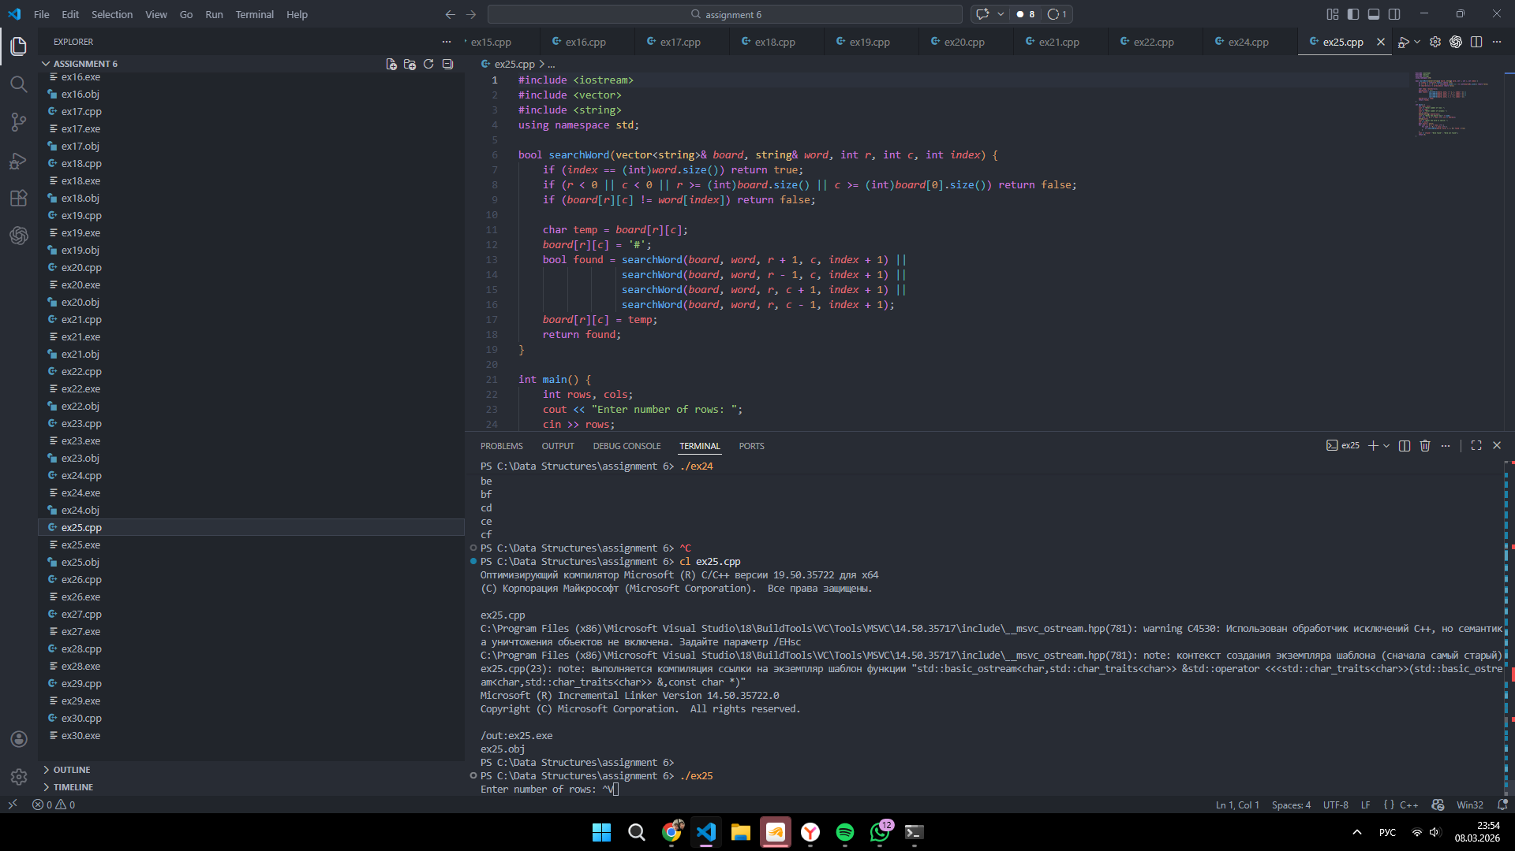
6 | Rat in a Maze  Task: A rat starts at (0, 0) in a 2D grid (maze) and needs to reach (N-1, N-1). Some cells are blocked (0) and some are open (1). Find a path the rat can take.  Example: Output a list of coordinates or a visual grid showing the path from start to finish.  Code (ex26.cpp):  #include <iostream>  #include <vector>  using namespace std;  bool solveMaze(vector<vector<int>>& maze, int r, int c, vector<pair<int, int>>& path, vector<vector<int>>& vis) {  int n = maze.size();  if (r < 0 || c < 0 || r >= n || c >= n) return false;  if (maze[r][c] == 0 || vis[r][c]) return false;  vis[r][c] = 1;  path.push_back({r, c});  if (r == n - 1 && c == n - 1) return true;  if (solveMaze(maze, r + 1, c, path, vis) ||  solveMaze(maze, r, c + 1, path, vis) ||  solveMaze(maze, r - 1, c, path, vis) ||  solveMaze(maze, r, c - 1, path, vis)) return true;  path.pop_back();  return false;  }  int main() {  int n;  cout << "Enter maze size N: ";  cin >> n;  vector<vector<int>> maze(n, vector<int>(n));  cout << "Enter the maze values (0 or 1):" << endl;  for (int i = 0; i < n; i++) {  for (int j = 0; j < n; j++) cin >> maze[i][j];  }  vector<pair<int, int>> path;  vector<vector<int>> vis(n, vector<int>(n, 0));  if (solveMaze(maze, 0, 0, path, vis)) {  cout << "Path:" << endl;  for (auto p : path) cout << "(" << p.first << ", " << p.second << ")" << endl;  } else {  cout << "No path found";  }  return 0;  }  Screenshot:  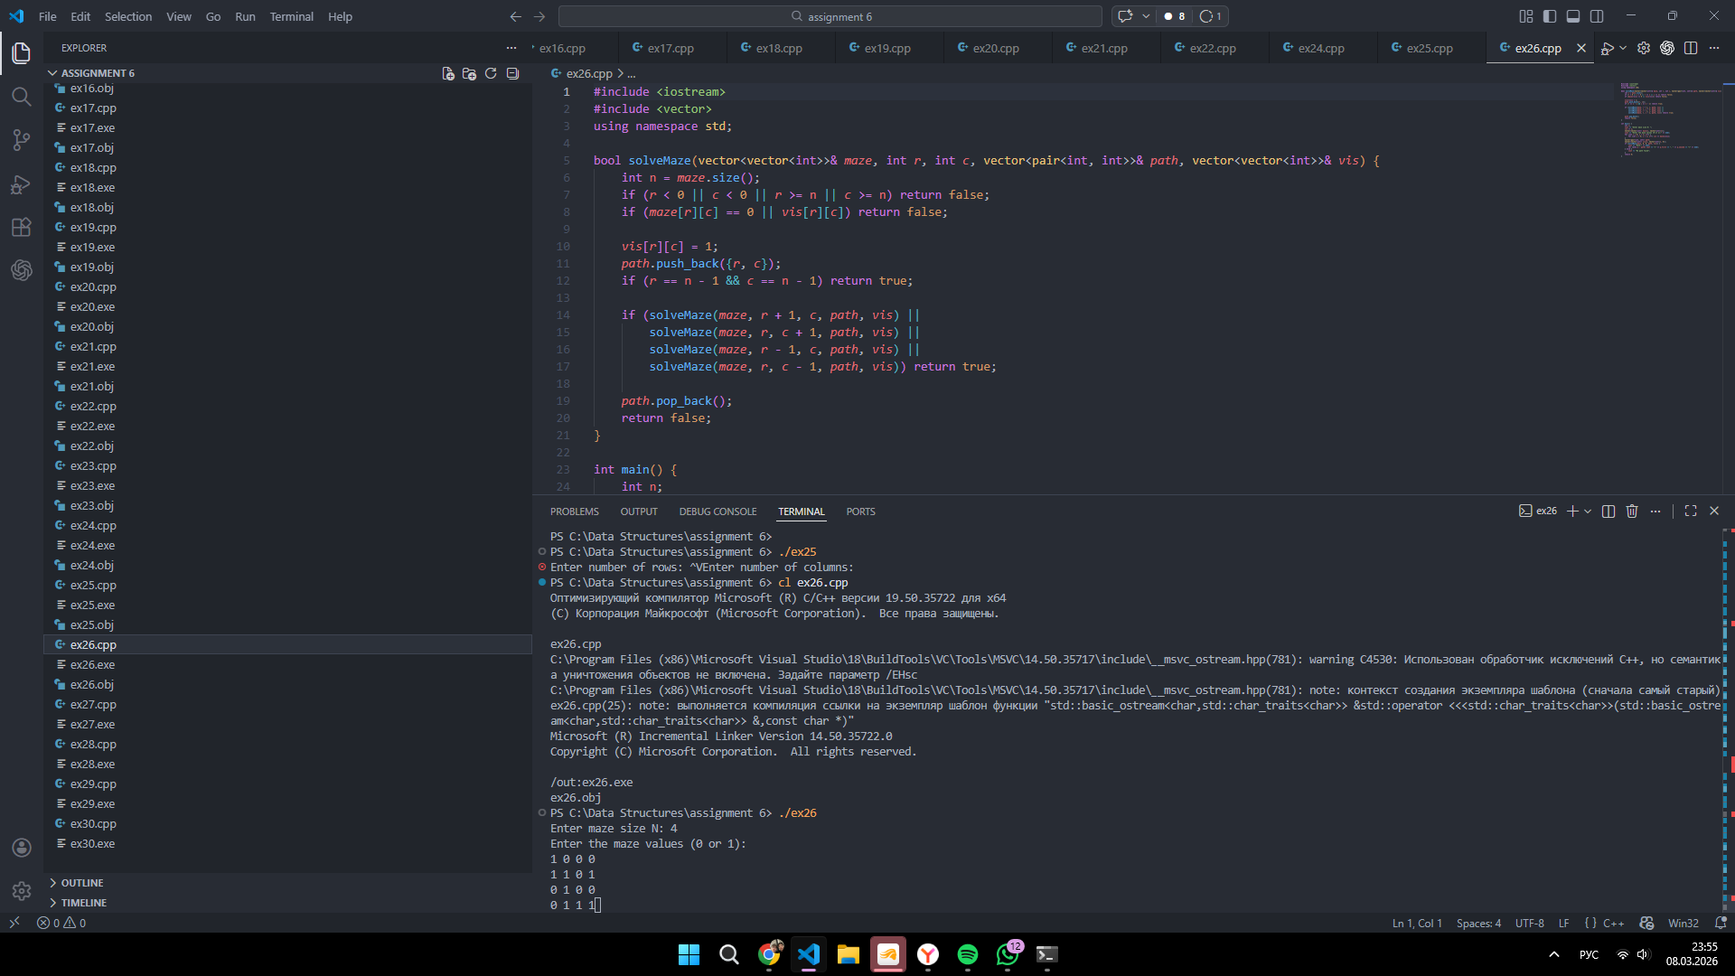
7 | Sudoku Solver  Task: Create a program that fills a partially completed 9 x 9 Sudoku grid. The solver must follow the standard rules: each number 1–9 must appear exactly once in every row, column, and 3 x 3 sub-grid.  Code (ex27.cpp):  #include <iostream>  #include <vector>  using namespace std;  bool isValid(vector<vector<int>>& board, int r, int c, int num) {  for (int i = 0; i < 9; i++) {  if (board[r][i] == num || board[i][c] == num) return false;  }  int sr = (r / 3) * 3;  int sc = (c / 3) * 3;  for (int i = 0; i < 3; i++) {  for (int j = 0; j < 3; j++) {  if (board[sr + i][sc + j] == num) return false;  }  }  return true;  }  bool solveSudoku(vector<vector<int>>& board, int cell) {  if (cell == 81) return true;  int r = cell / 9;  int c = cell % 9;  if (board[r][c] != 0) return solveSudoku(board, cell + 1);  for (int num = 1; num <= 9; num++) {  if (isValid(board, r, c, num)) {  board[r][c] = num;  if (solveSudoku(board, cell + 1)) return true;  board[r][c] = 0;  }  }  return false;  }  int main() {  vector<vector<int>> board(9, vector<int>(9));  cout << "Enter 9x9 Sudoku grid, use 0 for empty cells:" << endl;  for (int i = 0; i < 9; i++) {  for (int j = 0; j < 9; j++) cin >> board[i][j];  }  if (solveSudoku(board, 0)) {  cout << "Solved Sudoku:" << endl;  for (int i = 0; i < 9; i++) {  for (int j = 0; j < 9; j++) cout << board[i][j] << " ";  cout << endl;  }  } else {  cout << "No solution";  }  return 0;  }  Screenshot:  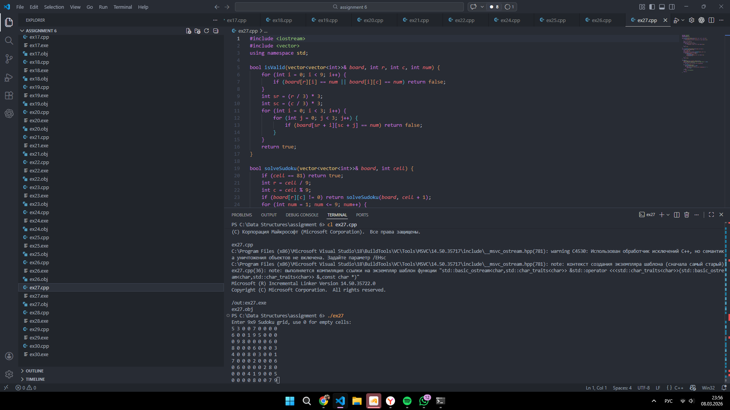
8 | The Knight’s Tour  Task: Given an N x N chessboard, a Knight starts at the first cell (0, 0). The Knight must move according to standard chess rules (in an "L" shape) and visit every square on the board exactly once.  - Goal: Output the grid showing the sequence of moves (1 to N^2).  Example: For an 8 x 8 board, the output would be a grid where each cell contains a number representing the order in which it was visited.  Code (ex28.cpp):  #include <iostream>  #include <vector>  #include <algorithm>  using namespace std;  int dr[8] = {2, 1, -1, -2, -2, -1, 1, 2};  int dc[8] = {1, 2, 2, 1, -1, -2, -2, -1};  bool inside(int n, int r, int c) {  return r >= 0 && c >= 0 && r < n && c < n;  }  int degree(const vector<vector<int>>& board, int r, int c) {  int n = board.size();  int cnt = 0;  for (int i = 0; i < 8; i++) {  int nr = r + dr[i];  int nc = c + dc[i];  if (inside(n, nr, nc) && board[nr][nc] == -1) cnt++;  }  return cnt;  }  bool knightTour(vector<vector<int>>& board, int r, int c, int moveNo) {  int n = board.size();  if (moveNo == n * n) return true;  vector<pair<int, pair<int, int>>> nextMoves;  for (int i = 0; i < 8; i++) {  int nr = r + dr[i];  int nc = c + dc[i];  if (inside(n, nr, nc) && board[nr][nc] == -1) {  nextMoves.push_back({degree(board, nr, nc), {nr, nc}});  }  }  sort(nextMoves.begin(), nextMoves.end());  for (auto move : nextMoves) {  int nr = move.second.first;  int nc = move.second.second;  board[nr][nc] = moveNo;  if (knightTour(board, nr, nc, moveNo + 1)) return true;  board[nr][nc] = -1;  }  return false;  }  int main() {  int n;  cout << "Enter board size N: ";  cin >> n;  vector<vector<int>> board(n, vector<int>(n, -1));  board[0][0] = 0;  if (knightTour(board, 0, 0, 1)) {  cout << "Knight's tour:" << endl;  for (int i = 0; i < n; i++) {  for (int j = 0; j < n; j++) cout << board[i][j] + 1 << " ";  cout << endl;  }  } else {  cout << "No solution";  }  return 0;  }  Screenshot:  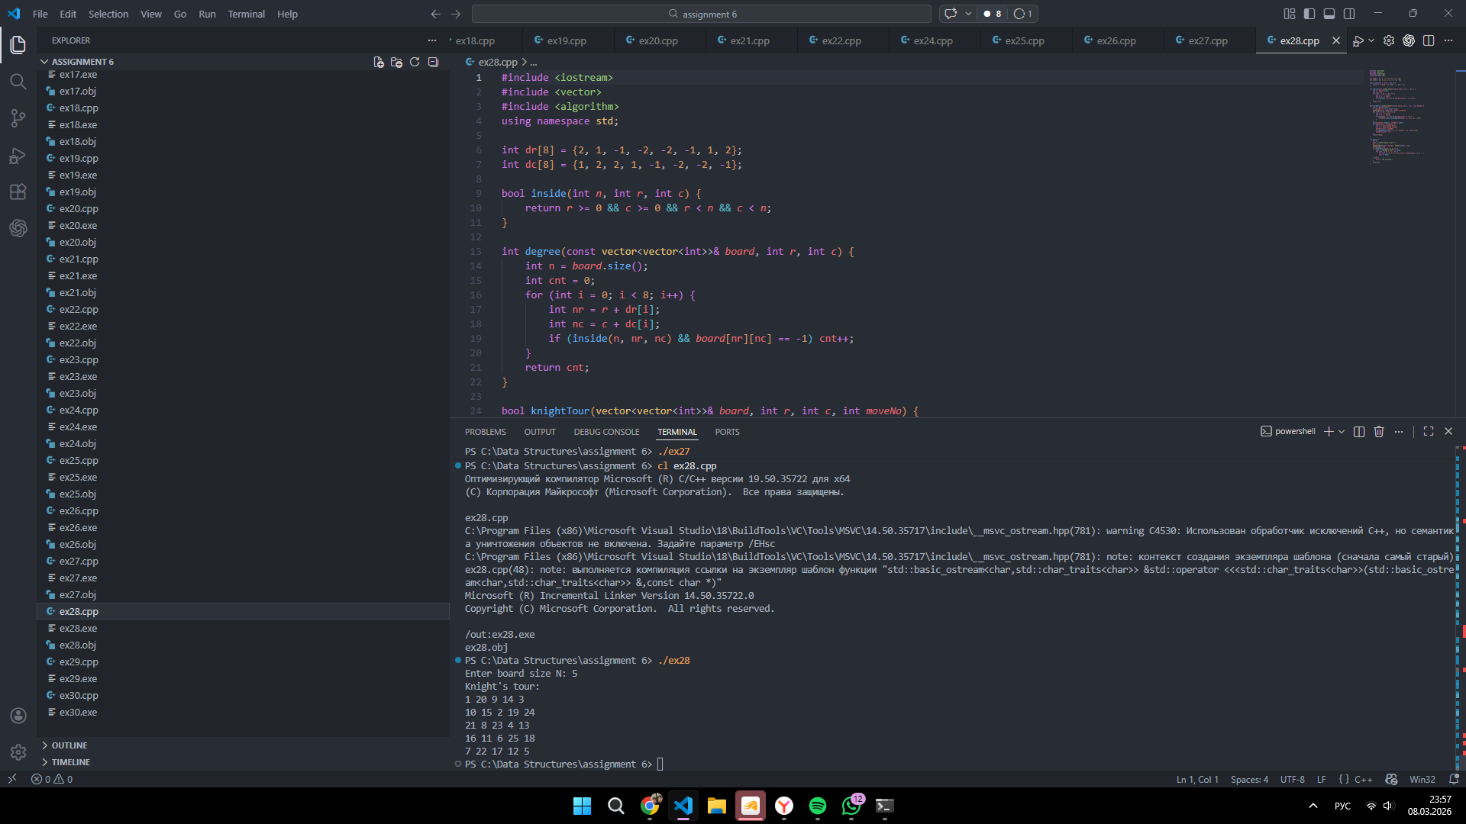
9 | N-Queens Puzzle  Task: Place N queens on an N x N chessboard such that no two queens attack each other (none share the same row, column, or diagonal).  Example: For N = 4, return the two distinct board configurations where queens are safe.  Code (ex29.cpp):  #include <iostream>  #include <vector>  #include <string>  using namespace std;  void solveQueens(int n, int row, vector<int>& col, vector<int>& d1, vector<int>& d2, vector<string>& board, vector<vector<string>>& ans) {  if (row == n) {  ans.push_back(board);  return;  }  for (int c = 0; c < n; c++) {  if (col[c] || d1[row - c + n - 1] || d2[row + c]) continue;  col[c] = d1[row - c + n - 1] = d2[row + c] = 1;  board[row][c] = 'Q';  solveQueens(n, row + 1, col, d1, d2, board, ans);  board[row][c] = '.';  col[c] = d1[row - c + n - 1] = d2[row + c] = 0;  }  }  int main() {  int n;  cout << "Enter N for N-Queens: ";  cin >> n;  vector<int> col(n, 0), d1(2 * n - 1, 0), d2(2 * n - 1, 0);  vector<string> board(n, string(n, '.'));  vector<vector<string>> ans;  solveQueens(n, 0, col, d1, d2, board, ans);  if (ans.empty()) {  cout << "No solution";  } else {  cout << "Solutions:" << endl;  for (auto solution : ans) {  for (string row : solution) cout << row << endl;  cout << endl;  }  }  return 0;  }  Screenshot:  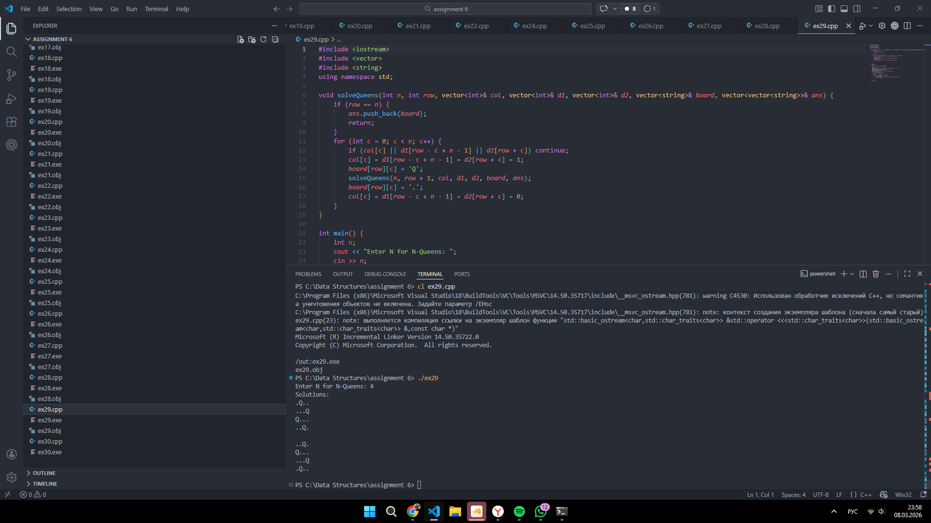
10 | Equal Sum Multi-Partition  Task: Given an array of integers and an integer K, determine if the array can be divided into K non-empty subsets such that the sum of elements in every subset is exactly the same.  - The Scenario: You have a pile of weights, and you need to distribute them into K identical boxes so that every box weighs exactly the same.  - Example: * Input: nums = [4, 3, 2, 3, 5, 2, 1], K = 4  - Target Sum: Total sum is 20, so each of the 4 subsets must sum to 5 (20 / 4).  - Output: True (One possible partition: [5], [1, 4], [2, 3], [2, 3]).  Code (ex30.cpp):  #include <iostream>  #include <vector>  #include <algorithm>  using namespace std;  bool canPartition(vector<int>& nums, vector<int>& bucket, int index, int target) {  if (index == (int)nums.size()) return true;  for (int i = 0; i < (int)bucket.size(); i++) {  if (bucket[i] + nums[index] > target) continue;  bucket[i] += nums[index];  if (canPartition(nums, bucket, index + 1, target)) return true;  bucket[i] -= nums[index];  if (bucket[i] == 0) break;  }  return false;  }  int main() {  int n, k;  cout << "Enter number of elements: ";  cin >> n;  vector<int> nums(n);  cout << "Enter " << n << " elements: ";  int sum = 0;  for (int i = 0; i < n; i++) {  cin >> nums[i];  sum += nums[i];  }  cout << "Enter K: ";  cin >> k;  if (k <= 0 || sum % k != 0) {  cout << "False";  return 0;  }  sort(nums.rbegin(), nums.rend());  vector<int> bucket(k, 0);  cout << (canPartition(nums, bucket, 0, sum / k) ? "True" : "False");  return 0;  }  Screenshot:  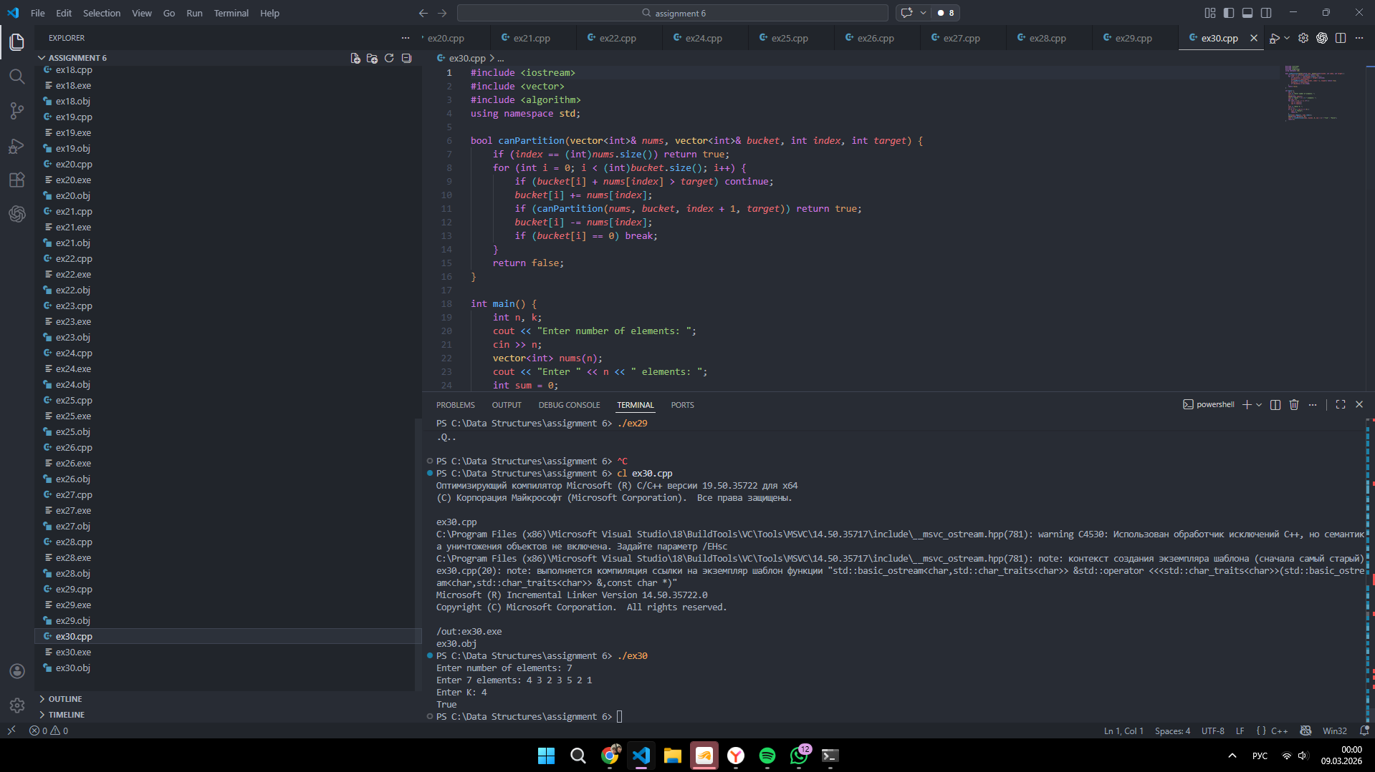

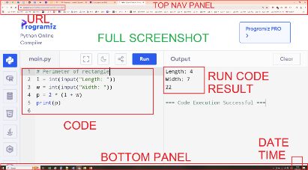
Submission Guidelines:
- Submit your Report with solution source codes as text.
- Clearly label each exercise in your submission.
- Exercises are due at the beginning of the next class.
- Solution codes has to be with full screenshots of code run result!
- Finally, whole Assignment Report should be uploaded on Moodle!

